**Input:**

**Input Description:**

Here we are using a text file as an input to our program. The first line of the text file contains the number of edges and vertex. The next lines of the text file contains the connectivity between two vertices. If the vertex 2 and vertex 3 is connected the we write 2 3 in the text file as a source destination pair.

* **Set 1:**

Input Graph (Diagram):

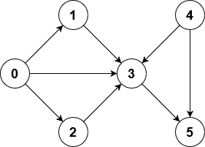

Input Text file representation:

8 6

0 1

0 2

0 3

1 3

2 3

3 5

4 3

4 5

* **Set 2:**

Input Graph (Diagram):

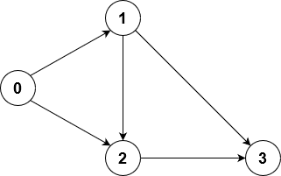

Input Text file representation:

5 4

0 1

0 2

1 2

1 3

2 3

* **Set 3:**

Input Graph (Diagram):

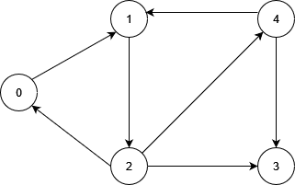

Input Text file representation:

7 5

0 1

1 2

2 0

2 3

2 4

4 3

4 1

**Output:**

* Set 1:

No. of edge is : 8

No. of vertices is : 6

The Adjacency Matrix is:

0 1 1 1 0 0

0 0 0 1 0 0

0 0 0 1 0 0

0 0 0 0 0 1

0 0 0 1 0 1

0 0 0 0 0 0

There is no initiator

The graph is dis-connected

* Set 2:

No. of edge is : 5

No. of vertices is : 4

The Adjacency Matrix is:

0 1 1 0

0 0 1 1

0 0 0 1

0 0 0 0

The graph is connected

The initiator vertices is: 0

0 1 2 3

* **Set 3:**

No. of edge is : 7

No. of vertices is : 5

The Adjacency Matrix is:

0 1 0 0 0

0 0 1 0 0

1 0 0 1 1

0 0 0 0 0

0 1 0 1 0

The graph is connected

There is no source vertex

0 1 2 3 4

Vertex 0 can be considered as initiator

1 2 0 3 4

Vertex 1 can be considered as initiator

2 0 1 3 4

Vertex 2 can be considered as initiator

4 1 2 0 3

Vertex 4 can be considered as initiator